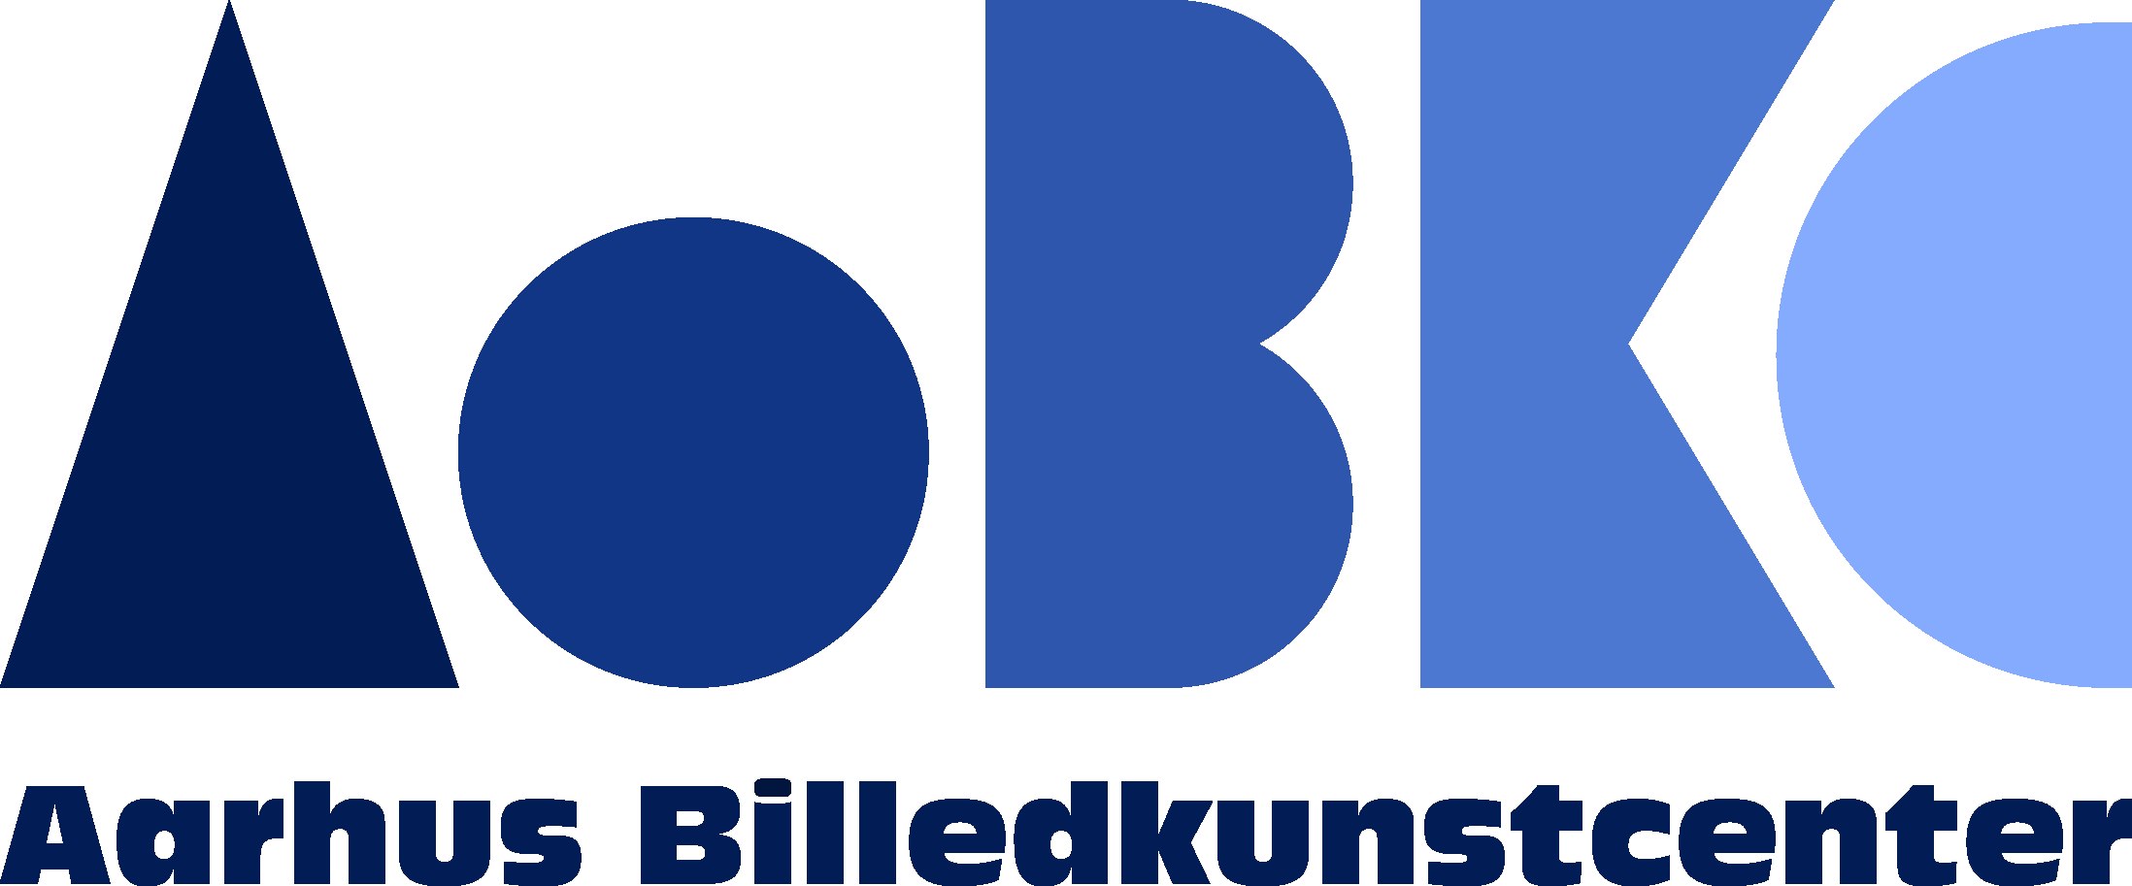

APPLICATION FORM – AaBKC RESIDENCY
SPRING 2019 (CURATOR)

Thank you for your interest in AaBKC Residency’s Spring 2019 curatorial program.
To apply, please send this completed form and all attachments (listed below) to residency@aabkc.dk by 23:59 (Danish time) on Friday, October 19, 2018.

Full Name:
Email:
Age:
Nationality:
City and country of residence:
Employment:
Website (if applicable):
How did you learn about AaBKC Residency?:

Please attach the following to create a single PDF document:
- Motivation letter (max. 500 words)
- CV (max. 2 pages)
- Curatorial portfolio presenting 3 recent projects (max. 5 pages)

For more information on AaBKC Residency, please visit aabkc.dk/page/aabkc-residency.
Please direct questions to Pamela Grombacher: international@aabkc.dk

