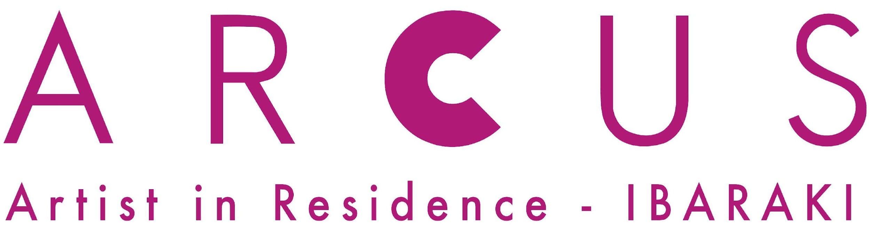

ARCUS Project IBARAKI 2023
ARCUS Research
APPLICATION FORM

FIRST NAME, LAST NAME | FOR APPLYING AS A GROUP, LIST ALL MEMBERS’ NAMES
NATIONALITY (as appears on passport) | DATE OF BIRTH (yyyy/mm/dd)
ADDRESS (Street, City, State, Postal, Country) | EMAIL
BILLING ADDRESS (if it is same as above, indicate as “same”) | PHONE (country code, area code, number)
WEBSITE or SNS handle name (optional) | GENDER (optional)
OCCUPATION | AFFLIATED ORGANIZATION(S)
SUPPORTING ORGANIZATION / FUNDING INSTITUTION  if applicable | FUNDING AND GRANT STATUS  Please specify the status of your funding/grant application including dates of results if you are applying
RESIDENCY PERIOD (check either one month or two months residency)
□ ONE MONTH RESIDENCY | □ TWO MONTHS RESIDENCY
For one month residency, please indicate your preferred period as “1” or “2” in parentheses.  ( ) June 9 Fri. – July 8 Sat. 2023  ( ) July 11 Tue. – August 9 Wed. 2023 | June 9 Fri. – August 9 Wed. 2023
ENGLISH PROFICIENCY | JAPANESE PROFICIENCY
Native・Fluent・Conversational・Basic ・None | Native・Fluent・Conversational・Basic ・None
ADDITIONAL SUPPORT (available with a fee / select ones that you would like to ask)
□ Interpretation (research / interview / event) □ Translation (English / Japanese)

□ Studio Visit

□ Coordination& attend for research, interview, etc.

□ Other supports specify:

HOW DID YOU HEAR OF ARCUS RESEARCH PROGRAM? (check all that apply)
□ ARCUS Project website /Facebook/Twitter □ E-Newsletter from ARCUS

□ Applied to ARCUS AIR before year(s) you applied:

□ Other websites/sources

□ From a friend/acquaintance/past participant □ From an organization/school

TWO REFERENCES (short-listed candidates may be asked to provide a letter from one of their references)
REFERENCE 1 | REFERENCE 2
- Name  - Title  - Institution (if any)  - Email | - Name  - Title  - Institution (if any)  - Email

