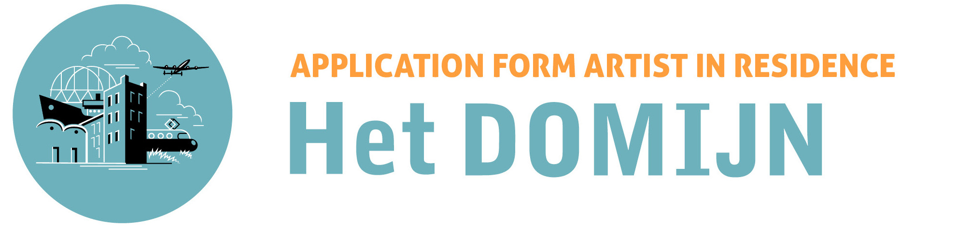

Applicant Information
Family Name
First Name
Nationality (on passport)
Date of Birth |  | Day/Month/Year
Male / female
Full Address |  | Street:  City:  State/Province:  Postal code:  Country:
Telephone number
Email address
Website
Bank account number
Occupation
Language Proficiency |  | English: Fluent / Advanced / Intermediate / Beginner
Field Information |  | Autonomous art / Applied arts / Performing arts / Craftsmanship, please specify:
Residency Period |  | Please specify how long you would like to stay from the date of start of your residency (3 to 5 months)  Month - day - year (as stated on the TransArtist website)  until Month - day - year
Education
Year | Month
Brief artist statement (less than 300 words)
Description of your plan according to the residence period (less than 500 words)
The following information is highly encouraged but not required:
- Project concept and expected result
- General plan/schedule for carrying out the project from start to finish
- Intended use of studio
- Form of final presentation of work/work-in-progress (exhibition, open studio, workshop, etc)
- Reasons for choosing AiR Het Domijn
Funding Information |  | Self-funded / Grant, scholarship / if other, please specify:
* Please specify funding information if applicable |  | Supporting organization:  Affiliation:  Position held (if applicable):  Email address:  Phone number:  Status □ Paid  □ Confirmed. Payment Date:  □ Under review. Result by:

After reading the terms and conditions below, please send this form to residency@hetdomijn.nl with the following information:
- Application form (including Artist statement and Description of your plan)
- Current curriculum vitae
- Portfolio / documentation
- Documentation list (title, description, date etc.)
Please do not send files bigger than 5MB, if you have large files please zip them and send them through an online file sharing service, with a maximum size of 50 MB.

Terms and Conditions of Residence Application
By submitting this application form the applicant agrees to the following:
- Applications must be made with the intent to take up the residency
- After receiving the invitation, the applicant has five days to respond to the invitation. If the invitation is not accepted within the specified time, the invitation will expire
- Applicants must be able to cover the cost of the residence
- Upon accepting uptake of the residency cancellation will incur a cancellation fee of € 650,-. The cancellation fee must be paid directly after accepting the residency. You will receive an invoice for this. After the start of residency, the cancellation fee shall be the first month's rent.
- The remaining rent shall be paid as a single lump sum at the start of the period stated in the agreement (contract) that you will receive after accepting the residency.

Signature …………………………………………….. Date…………..
If you have any questions please contact residency@hetdomijn.nl
Residence Program Coordinators: Mirjam Langemeijer & Maaike Fransen.

Thank you for your interest in AiR Het Domijn Open Call. We look forward to hearing from you!

