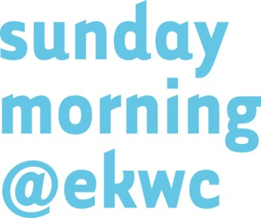
application form 2022
Please not that sundaymorning@ekwc can only accept digital applications.
Make sure the application has been completed in full and is accompanied by the requested documentation uploads.
If you are admitted, the documentation becomes property of sundaymorning@ekwc. If your application is not complete or in compliance with these conditions, we will regretfully refuse it for review.
1.Personal information
First Name …..………………………………………………………………………………………………………………..
Surname ……………………………………………………………………………………………………………………..
Date of birth …………………………………………………………............................................................
Returning resident? Yes ........ No ........
Have you stayed with us before?
Gender Male ………. Female ……….
Nationality ……………………………………………………………………………………………………………………..
Adress ……………………………………………………………………………………………………………………..
Postal code ……………………………………………………………………………………………………………………..
City ……………………………………………………………………………………………………………………..
State/province/region ……………………………………………………………………………………………………………………..
Country ……………………………………………………………………………………………………………………..
e-mail ……………………………………………………………………………………………………………………..
Phone number ……………………………………………………………………………………………………………………..
Mobile number ……………………………………………………………………………………………………………………..
Skype ……………………………………………………………………………………………………………………..
Website ……………………………………………………………………………………………………………………..
I play the piano Yes ........ No ........

2.Discipline
Please check the discipline in which you graduated:
….. Visual artist ….. Ceramist ….. Designer
….. Architect ….. Writer ….. Composer
….. Chef ….. Other ……………………………………………………………
3. Please enclose the following attachments to application
3a CV
Please state experience, training, course(s), exhibitions, projects and publications that in your view are relevant to your present activities.
3b Work plan
A brief (not more than 1 page) explanation in English or Dutch of motivation and/or plans concerning the residency in relation to present work plus a visual print or drawing to support your plan.
3c Images
Please send max. 5 images. The title of images must contain your surname, the year and a number in chronological order from old to new (for example: Johnson 2004_01.jpg) corresponding to the image list below (starting with the eldest work in chronological order).

4.Costs of a residency
Herewith you declare your awareness of the costs of a residency and your obligation to pay for the expenses involved. Fee for a 12 weeks’ residency (incl. advice, studio, guestroom, use of workshops, VAT): € 21.780
Plus an advance payment for firing, materials, transport and cadcam: € 2.000
Participants can apply for a Sundaymorning grant up to € 1476,20 per week (incl. 21% VAT).
I want to apply for a Sundaymorning grant: Yes ........ No ........
5.Newsletter
I would like to subscribe to your newsletter: Yes ........ No ........

6.Pay Application fee
A contribution to administration cost of € 35 is payable for each application. This amount must be paid with the application. Your application will not be reviewed before the fee has been received. Note: sundaymorning@ekwc accepts online payments only! After submitting this form we kindly ask you to transfer the amount of € 35 to our bank account NL66 INGB 0004 2469 47, BIC-codenumber INGBNL2A.
By submitting this application you agree to our terms and conditions stated above.

